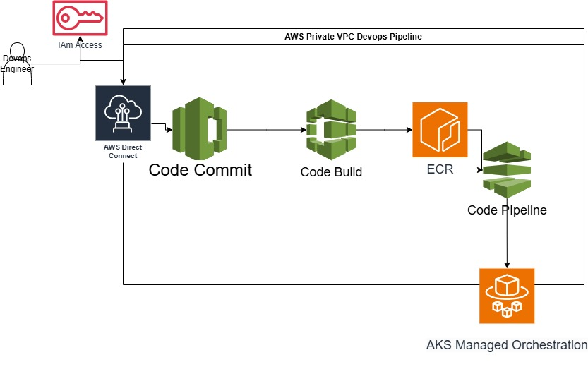In today’s era of always-on services and hyperautomation, technical leaders are tasked with delivering stable, secure, and continuously evolving software. The days of ad-hoc scripting and patchy deployments are behind us. Organizations that cling to mutable, manual processes or neglect to invest in DevOps pipelines soon realize they’re running uphill against modern engineering practices, often at the risk of missed market opportunities and security lapses.

But what does it mean to “do it right,” and how does one ensure that their architecture can handle growth, innovation, and the potential for AI-driven development? Let’s explore the nuanced differences between mutable and immutable deployment strategies, the critical role of DevOps, and why securing your software delivery pipeline within private networks is becoming a mandate, not just a preference.

**The Business Landscape: Why Architecture Choices Matter**

Before diving deep into deployment patterns, it’s important to recognize that software engineering decisions impact the entire business. Companies that adopt robust, automated deployment pipelines and secure their environments gain:

**Faster Time-to-Market**

Automated pipelines cut down on manual tasks, ensuring new features and bug fixes are released quickly and consistently.

**Reduced Operational Risk**

Immutable deployments and versioned artifacts mean you can roll out updates with minimal downtime and fewer production surprises.

**Scalability and Agility**

Solid DevOps practices allow for effortless scaling—crucial when your user base or data-processing demands can spike unpredictably.

**Stronger Security Posture**

By running critical processes within private networks (e.g., a private VPC on AWS), you significantly reduce the exposed surface area to external threats.

In short, architectural decisions aren’t just technical details. They’re strategies that can drastically affect a company’s bottom line and reputation.

**Part I: Mutable vs. Immutable Deployments—A Paradigm Shift**

**Mutable Deployments: Simple, but Risky**

Mutable deployments are often born out of necessity or limited scope. It’s the most straightforward way to ship software if you’re a small team or simply automating a once-manual process:

Immediate Changes, Immediate Risks

You can update code or configuration directly on a running instance. While this is convenient, the chance of introducing a bug or downtime is high.

Common Use Cases

Early in a product’s life cycle, teams might rely on shared Jupyter notebooks or even Excel-based workflows where “pushing to production” might mean someone manually uploading a file or script.

Fragile Reliability

A single errant configuration update can stop an entire service, leading to a chaotic scramble to restore functionality.

Although mutable deployments get you up and running quickly, they become fragile as user demand grows or the team scales up. A single environment that’s routinely being poked and prodded is an environment that’s perpetually one small error away from a full-blown outage.

Immutable Deployments: The Modern Standard

Immutable deployments represent a more forward-thinking approach—an antidote to the pitfalls of mutable systems:

Reliability Through Artifacts

Rather than patching a running environment, you create a brand-new version of the application (often packaged in a Docker image) for every release. This artifact is deployed fresh into production, meaning you always know the exact state of what’s running.

**Scalability and Automation**

With immutable deployments, scaling out is as simple as spinning up more instances of the same container image in platforms like AWS ECS Fargate, EKS, or Azure Kubernetes Service (AKS).

**Zero-Downtime Releases**

Using deployment strategies like blue-green (where two parallel environments are maintained) or canary (where a small subset of users sees the new version first) significantly reduces disruption. The new version is tested, validated, and only then swapped into service.

**Predictability**

Because you never modify a “live” instance, each new deployment is identical across environments. This dramatically reduces the dreaded “works on my machine” problem and speeds up debugging.

For organizations seeking high availability and minimal disruption, immutable deployments have become the modern standard. It shifts engineering focus away from “fix it now” firefighting into a more streamlined, automated approach to delivering change.

**Part II: The Rise of DevOps—Why Pipelines Are Essential**

**Automation and Efficiency**

As AI starts generating boilerplate code, teams must elevate their game beyond rote coding tasks. DevOps—an umbrella term for the cultural and technical shifts enabling continuous integration and continuous delivery (CI/CD) ensures that any code (machine-generated or otherwise) makes it into production safely and swiftly.

**Key Advantages of a Strong DevOps Pipeline:**

**Continuous Integration:** Automated tests immediately run against every commit, catching issues early before they snowball.

**Continuous Delivery:** Code pipelines allow safe, repeatable releases—no last-minute frenzy.

**Monitoring & Observability:** Enhanced logging, metrics, and alerting help measure performance and capture insights for improvement.

**Bridging Development and Operations**

DevOps professionals serve as the glue between development and operations, ensuring that the code developers write aligns with the practical realities of running in production. This is especially critical for advanced deployment strategies like blue-green or canary, which rely on smooth handoffs between code repositories, container registries, and the final production environment.

**________________________________________**

**Part III: Securing the Pipeline with Private Networks**

As the sophistication of attacks increases, securing the DevOps pipeline is not an option—it’s an imperative. The more integrated your pipeline (and the more it touches sensitive infrastructure), the more attractive a target it becomes.

**Private VPCs in AWS**

One of the most robust ways to secure your pipeline is to run it inside a private Virtual Private Cloud (VPC) on AWS. This setup offers:

**Network Isolation:** Only authorized endpoints can communicate with your build processes.

**Granular Access Control:** Security groups and network ACLs provide fine-grained control over ingress and egress.

**Compliance-Ready:** Regulated industries often mandate that sensitive data and operations remain within controlled network boundaries.

**Key AWS Services for a Secure Pipeline**

**AWS Direct Connect**

**Private Connectivity:** Bypass the public internet entirely, reducing latency and exposure.

**Hybrid Environments:** Maintain a secure connection to on-premises data centers while leveraging AWS for scaling, it can be a good Idea to reduce costs while keeping your data on your own premises, however note that the need for overhead support on security and maintenance is going to incrase compared to those of a fully cloud architecture.AWS CodeCommit

**Private Git Repository**: Keep source code away from public hosting platforms.

**Version Control and Security**: Coupled with AWS Identity and Access Management (IAM), you ensure only the right people have the right level of access.

**AWS CodePipeline**

**Orchestrated Deployments:** Automatically triggers builds, tests, and deployments on new commits.

**End-to-End Traceability:** Central place for logs and audit trails, crucial for compliance.

**AWS CodeBuild**

**Private Builds:** Compile and test within an isolated environment, ensuring no secrets leak.

**Scalable:** Spin up multiple builds in parallel without manual resource management.

**________________________________________**

**Part IV: Deployment to Managed Orchestration Platforms**

**After the code is built and tested, the ultimate question is: where do we deploy? While AWS provides ECS and EKS, real-world scenarios may involve deploying to AKS (Azure Kubernetes Service) or other container orchestrators. This multi-cloud or hybrid approach emphasizes flexibility but also underscores the need for secure networking and consistent deployment artifacts.**

**Multi-Cloud and Hybrid Scenarios**

**Consistent Artifacts: By packaging your application as Docker images, the same build outputs can be seamlessly deployed to AKS, EKS, or ECS.**

**Networking Considerations: AWS Direct Connect or site-to-site VPNs ensure your container images, logs, and monitoring data traverse private links, maintaining security even across cloud boundaries.**

**Operational Simplicity: Tools like Helm charts (for Kubernetes) can standardize deployments across platforms, further reducing friction.**

**________________________________________**

**Part V: Why Companies Can’t Afford to Lag Behind**

**The High Cost of Manual or Mutable Processes**

**Organizations that rely on mutable deployments, manual build steps, or a single developer pushing code to a live server risk:**

**Extended Downtimes: Small mistakes can spiral into production outages, eroding customer trust.**

**Slower Releases: Manual steps add friction, causing bottlenecks that delay time-to-market.**

**Security Vulnerabilities: Publicly exposed build servers or repos increase the risk of data leaks and supply chain attacks.**

**The Competitive Edge of Immutable Architectures and DevOps Pipelines**

**By contrast, companies embracing immutable deployments and automated pipelines stand to gain:**

**Increased Innovation Velocity: Developers can focus on feature development rather than deployment firefighting.**

**Better Resilience: Zero-downtime updates, quick rollback capabilities, and ephemeral environments.**

**Stronger Security: Versioning and ephemeral nature of containers limit the blast radius of any malicious attack.**

**In the face of a rapidly evolving technology landscape—compounded by the rise of AI capabilities—staying behind on deployment best practices is simply not an option. Embracing modern DevOps pipelines and immutable deployment strategies isn’t just an internal process improvement; it can be the defining advantage that separates industry leaders from laggards.**

**________________________________________**

**Conclusion: Future-Proofing with Immutable Deployments and Secure Pipelines**

**As businesses scale from ad hoc Excel-based processes to sophisticated cloud-native architectures, the demand for secure, reliable, and automated software delivery intensifies. Mutable deployment methods might get you started, but they quickly become a liability when you need high availability and robust security.**

**By contrast, immutable deployments—bolstered by advanced techniques like blue-green and canary releases—are the gold standard for reducing downtime and ensuring predictable releases. A well-structured DevOps pipeline running inside a private network not only prevents external threats but also gives teams the freedom to focus on innovation rather than patching production environments.**

**In short, those who fail to adopt these modern practices risk being outpaced by competitors who can deliver features faster, safer, and at a lower operational cost. Investing in immutable deployments, secure DevOps pipelines, and private networking isn’t just smart—it’s essential for any organization serious about thriving in the next wave of technical evolution.**

**________________________________________**

**Key Takeaways**

**Architecture Matters: Thoughtful design choices in deployment methods and pipelines can significantly impact your company’s agility and stability.**

**Immutable > Mutable: Transitioning to immutable deployments reduces risk and sets the stage for zero-downtime updates.**

**DevOps Is Foundational: AI may handle routine coding, but DevOps is critical for orchestrating releases, ensuring security, and maintaining resilience.**

**Private Networks for Security: Running builds and storage within private networks (like an AWS VPC) minimizes attack surfaces and meets regulatory requirements.**

**Don’t Lag Behind: Organizations that neglect modern CI/CD and immutable deployments risk higher downtimes, slower releases, and lost competitive edge.**

**The world is moving fast, and those who ignore the call to upgrade their pipelines and deployment strategies do so at their own peril. By embracing the strategies outlined above, you position your company for success in an ever-accelerating digital landscape.**